St Andrews C of E Junior School
Forest School Handbook

This handbook is accessible to all staff and parents/carers taking part in the session and available on the School Website.

Page Contents
2 Background & Ethos
3 Our Vision
3 Our site
4 A typical session

Policy Statements

5 Communication
5 Equal opportunities
6 Control of substances hazardous to health
6 First aid, accident, emergency and incident reporting
7 Adverse weather
8 Beaufort scale
9 Behaviour
9 Safeguarding
9 Staff, visitors and volunteers
10 Food hygiene
11, 12 Welfare
12 PPE
13 Manual Handling
13 General site and environmental considerations
14 Play
14, 15 Emotional well-being
16, 17 Fire policy
18 - 22 Clothing guide & seasonal wear and care

23 Dynamic Risk Assessment

24 Tool use policies and procedure - (for Site use only)
25 Billhook
26 Bowsaw
27 Junior hack saw
28 Flint striker
29 Loppers
30 Mallet
31 Palm drill/gimlet
32 Safety whittler
33 Secateurs
34 Sheath Knife
35 Kelly Kettle

Booklets:

Risk Assessments & benefits

Woodland management plan and ecological impact assessment

Background

The Forest School concept originated in Scandinavia in the 1950’s. A child-centred, holistic approach originally aimed at pre-school children, it was found that children who had attended forest school then arrived at school with strong social and communication skills; with the ability to work in groups effectively; and generally possessing high self-esteem and confidence in their own abilities. These foundations helped them to raise their academic achievements later in life.
In a world of mobile phones, I-Pads, computer games and health & safety, children spend less and less time playing outside and these types of opportunity have become more and more important.

The Forest School Ethos

Forest School is a unique educational experience that offers children the opportunity to succeed and develop confidence and self-esteem through hands-on learning experiences in a woodland environment.
Children have time and space to follow their own interests and test their own limits: to take risks, challenge themselves and return to those challenges again and again, consolidating and building on their previous experience. They engage in motivating and achievable tasks and activities throughout the year. They will work with tools, play, learn and begin to understand the boundaries of behaviour, both physical and social. They will learn to collaborate and work as a team, to take care of themselves, each other and their environment. Through these experiences they will grow in confidence and self- esteem; develop resilience and a sense of mastery, whilst developing an understanding of the natural world. The ethos also encapsulates our Global Education School accreditation whilst complementing our MACAWS mental health.

Our Vision
At St Andrews Forest School we aim to provide opportunities for the children to:
- Develop personal and social skills
- Work through practical problems and challenges
- Use tools to create and build
- Pursue knowledge that interests them
- Learn how to manage failures
- Build confidence in decision making and evaluating risk
- Develop practical skills
- Explore connections between humans, wildlife and the earth
- Regularly experience achievement and success
- Reflect on learning and experiences
- Develop language and communication skills
- Improve physical motor skills
- Become more motivated
- Improve concentration skills
- Explore the world through their senses

Our Site

Our forest school takes place within our own school grounds. The site consists of a small variety of established trees such as birch, willow, hawthorn and evergreens such as holly. There are some areas of bramble and nettle bordering which have also had wildflower seed bombs added. Children have planted over 320 saplings to create a wild hedgerow and copse area. Also, we have planted an orchard including Wildflowers at our Office entrance.
We have a wonderful mud kitchen area the children can create and let their imaginations run wild.
Children are encouraged to respect and care for the environment by observing the plants and animals that inhabit the site, to only dig in specified areas, to use sticks they find on the ground and not break branches or pull leaves from trees.
The site is easily accessible from the school and children can return to the school to use the toilets. Public access to the site is restricted and monitored. Drinking water (children bring their own) and hand washing water / antibacterial gel are always available on site.

A Typical Session

Each session has a maximum of half a class size and is led by a qualified Level 3 Forest School Practitioner with the support of a class TA where possible. We also welcome parent helpers.
Our Forest School sessions run on a rolling program throughout the year. Your child will typically attend sessions in Year 3,5 and 6. Unless weather conditions are deemed unsafe (extreme cold or high winds), sessions will take place come rain or shine!
Each year group will receive up to six sessions /academic year where possible and dependant on class size.
One important aspect of Forest School is that children can follow and build upon their own experience and interests, meaning that each group’s sessions may evolve in different ways. Below is just an example of how a session may initially be structured:
Each session begins with the group gathering together and a welcome. This may be followed by a story, usually with an environmental message which will then link to an activity. The activity is modelled and then the children are free to choose if they wish to do the activity or explore and play in the Forest School area. Children may build dens, climb trees, play hide and seek, play with sticks, use tools or relax in a hammock, amongst other activities. Towards the end of the session, the group re-gathers to share a snack, sometimes hot chocolate, a toasted marshmallow, popcorn or some other treat that has been made or cooked on the fire! The children are then encouraged to help tidy the site, ensure the fire is out and help carry any equipment back to the school building (leave no trace, respect nature).
Each week, the previous activity/craft/ tools are available for the children to retry and build on any emerging skills.

Policies and Procedures

1) Communication

Policy
At St Andrews Forest School we believe communication is vital to ensure the smooth running, success of the sessions and holistic development of the child. We aim to keep parents, staff, volunteers and governors informed of what we do.

Procedure
The children can have a learning journal which they can used to add their thoughts and ideas into for reflection.
Where necessary, communication with parents will be via the Class dojo, Teacher or TA. If necessary, a time can be arranged to speak to the Forest School Leader, please contact the school office to arrange. Forest Dojo for the group will be set up for communication giving additional information and updates.
Information and photos of the session will be posted on the Forest School Dojo group.
Any other photographs taken will be in line with the school policy and parent authorisation already collected and outlined in the school policy. All staff are aware of and have read the above policy.

2) Equal Opportunities

Policy
In Forest School we are committed to providing equality of opportunity and an inclusive curriculum to all in line with the St Andrews policy.

Procedure
All staff are aware of and have read the above policy. In addition, all staff are responsible for ensuring that activities are differentiated according to individual abilities to ensure every child has access to all opportunities and barriers to learning are reduced or removed. Staff and children also have a responsibility to maintain paths and access to ensure the site is accessible to all. Inclusive behaviour will be modelled at all times and opportunities for children to work together in groups will be provided.

3) Control of Substance Hazardous to Health (COSHH)
No hazardous materials will be used on site.

4) First Aid, Accident and Emergency, and Incident Reporting

Policy
At Forest School we aim to ensure that we have adequate and appropriate facilities for providing first aid on site and clear procedures in the case of emergencies. At least one qualified First Aider will be on site at all times and a class first aid / burns pack available. Walkie-talkies connected to the School are used on site in case of an accident or emergency which requires additional help.
It is our aim to keep ourselves, the children and other participant’s safe at all times. To inform and learn from any incidents, all minor and major incidents will be recorded (online on school medical tracker), reflected upon and procedures reviewed.

Procedure
Minor incidents - Forest School first aider to examine child and determine what first aid, if any, is required on site. The incident will be logged on medical tracker.
Major incidents - Additional adult help will be requested, first aid applied on site if needed, ambulance called if required and remaining children returned to classroom. Incident will be logged and Parents informed.

Insect bites and stings - can be common, particularly in spring and summer, and usually cause only minor irritation. In rare cases, people can have a serious allergic reaction to a bite or sting that requires immediate medical treatment.
If there is prior knowledge to suggest that a child will have an allergic reaction if bitten, then the Forest School Leader must be informed before any activities take place on site. If ticks are known to exist in proximity to a site then all participants need to check or be checked for ticks as soon as possible following any activity on site. Where a tick is found on a participant, a plaster should be placed over it and parents/carers informed at the end of the session so that they can remove it safely. Information on safe removal of ticks can be found at www.tickbitepreventionweek.org/tick-removal (See Appendix 4 for Lyme disease information)
All staff are aware of and have read the above policies.

5) Adverse Weather

Policy
Our aim is to provide Forest School sessions whatever the weather, therefore it is vital that children have suitable clothing for the session. It is always recommended that children wear long sleeves and long trousers to limit scratches and grazes. Appropriate warm or waterproof layers need to be added in cold or wet weather, including hats and gloves if needed.
Sessions will only be cancelled due to school closure Policy, thunder storms, extreme cold or windy conditions when the Forest School Leader deems it to be unsafe or in the event of Forest School Leader absence. As a rule of thumb, if a yellow or above weather warning for the area has been issued by the MET office then a session may be cancelled. Winds or gusts above 6 on the Beaufort scale will also result in cancelation. Children will remain in their classrooms as normal if this occurs.
Due to lack of space in the timetable, it may not be possible to make up sessions.

Procedure
The Forest School Leader will inform the class teacher or TA if the session is to be cancelled. Should weather conditions deteriorate whilst a session is in progress, then the children will be returned to the classroom.
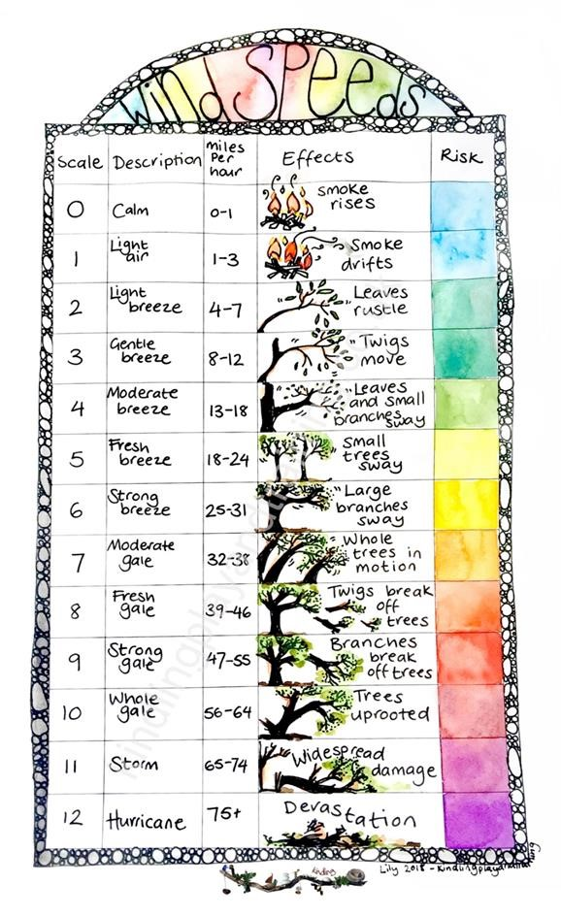

6) Behaviour

Policy
In Forest School we aim to provide a nurturing, respectful and safe environment. We aim to develop positive relationships between staff, children and the environment and encourage behaviour that promotes the Forest School ethos. Unsafe or unacceptable behaviour will be dealt with in line with the school Behaviour Policy.

Procedure
All staff are aware of and have read the Behaviour Policy. Any unkind behaviour is talked through with the children concerned and procedures followed according to policy. All staff model desired behaviour and consider the risk-benefit assessments when dealing with play which may involve an aspect of risk, such as stick fighting, before preventing such play. Dynamic risk assessments are undertaken where necessary. Communication with parents and teachers is essential for informing Forest School staff of any issues which may impact a child’s behaviour. Any persistent behaviours will be discussed and ways to tackle these implemented and reviewed regularly in order to inform future sessions.

7) Safeguarding

Policy
We have an essential role to play in safeguarding and promoting the welfare of all children. We aim to provide an ethos and environment at school where children feel safe, secure, confident, respected and listened to. We aim to prevent abuse, protect, support and work with parents and other agencies to achieve these goals.

All staff are aware of and have read the Safeguarding Policy.

8) Staff, Visitors and Volunteers
At St Andrews Forest School we value the positive influence that parents and other volunteers can contribute to the children’s learning and development. We also recognise the professional development that can be achieved through sharing experiences with other professionals. We aim to make volunteers and visitors feel welcome, whilst also ensuring they are aware of correct procedures, safety rules and conduct. The law requires all regular volunteers to have undertaken a DBS check.

Procedure
Parent helpers and visitors have access online to the handbook and can be given a copy of the handbook to read before the session if no online access.

9) Food Hygiene Policy
Cooking a treat on the fire is a fun and enjoyable aspect of Forest School. We aim to model good hygiene, safe food preparation and storage whilst providing them a tasty snack.
St Andrews is a Nut Free school. The class Teacher is to advise the Forest School Leader of children with known allergies; so that they do not consume these allergens whilst taking part in Forest School.

Procedure
All Forest School Leaders are qualified or undertaking Level 2 in Food Hygiene.
Hand washing is modelled and encouraged before any food preparation or eating. Hand washing water, soap and paper towels are available.
All food items are stored correctly and use by dates checked.
Food waste is, where possible, removed from the site and disposed of in the appropriate bins.
All litter is to be removed from the site and disposed of in the appropriate school bins.
Leave No Trace.

10) Welfare Requirements

Policy
The welfare of all Forest School participants is a priority. Whilst acknowledging that children need to participate in activities which provide some risk, all efforts will be made to ensure that sessions are a positive and enjoyable experience for all.


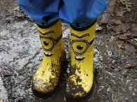
Procedure
At least one member of staff on site is a trained first aider.
We expect parents, class teachers and other staff to inform us of any health, emotional or medical issues that may require special treatment, such as allergies.
The children will always be registered by the class teacher then sent/accompanied to their session by a class TA or Forest School Leader.
A snack break is provided during the session, when possible, and drinking water (children bring their own water bottle and healthy alternative snack if required) is available at all times. Children will be encouraged to wash hands before eating.
In cases of extreme weather, either hot, cold or wet, staff will ensure that appropriate measures are in place, such as shelter from the sun or rain, and monitor children for signs of hypothermia or dehydration. Fore4st school leader will monitor and children can be returned to classrooms earlier if needed.
Activities may be altered to take into account any hazards presented by the weather.
Appropriate clothing and footwear is vital for comfort.
Please see list below for suggested items: It's as simple as 1, 2, 3: a base layer, a layer of warm play clothes and an outermost waterproof layer.
Wet/cold Hot/dry
Wellies/ walking boots with thick socks Sun hat and sun screen
Waterproof outerwear Thin, long sleeved top
Hats Thin, long trousers
Gloves Trainers

Toileting
Children go to the toilets before attending the session. However, we recognise that children may need to go again during the session. Children will be allowed to go themselves at the discretion of the Forest School Leader or TA.

11) Personal Protective Equipment

Policy
The safety of the children, staff and volunteers is paramount and the correct safety equipment will be available at each session for the planned activities. Instruction in the correct PPE and mode of use will be given.

Procedure
PPE is provided where required, as specified in the individual tool procedures and individual risk assessment for tools and activities. Staff, volunteers and children will be instructed on the correct use and when required.
Staff will model correct usage of PPE.
The Forest School leader will check the condition and presence of correct equipment before each session.
These may include fire safety gloves, work gloves and safety goggles.
***************************
If appropriate clothing is not worn it may be considered necessary to restrict certain activities or
Children return to the classroom early. The school has a small selection of waterproofs if needed.
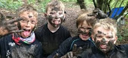

12) Manual Handling

Policy
At times Forest School may require the handling of heavy loads or carrying of equipment. To avoid serious injury from the incorrect handling of such items, we recommend the following considerations are made:

Procedure
- Firstly, does the item need lifting, or can it be rolled or put in a wheelbarrow?
- Does it require two people? If so, ensure communication is maintained between you when lifting, turning or lowering the item.
- Lift by bending the knees and keeping your back straight.
- Take regular rests if required.
- If possible, carry items in a ruck sack which divides the weight between both shoulders.
13) General site and environmental considerations

Policy
Care of the environment is a fundamental part of the Forest School ethos and we aim to inspire a love and respect for the natural world. We do this by using appropriate stories, modelling correct behaviour and teaching the children to be aware of their environment and the habitats around them.

Procedure
Whilst giving the children freedom to play, explore and discover in the environment, we, where possible, aim to:
- Remove all litter from the site and encourage an understanding of recycling and composting.
- Involve the children in observing wildlife, creating new habitats and protecting vulnerable areas.
- Take nothing from the environment.
- Use natural materials where possible for craft and activities.
- Assess the ecological impact of activities on the site and create a 3 year woodland management plan.

14) Play

Policy
Play is an extremely important factor in the healthy development of children. When playing children are able to be creative, develop their imagination, dexterity, physical and cognitive functions and also their emotional resilience. Play promotes healthy brain development and through play children can engage and interact with the world around them.
We aim to provide opportunities for the children to engage in free play whenever possible.
Procedure
Staff at Forest School have an understanding of the principles of play and reflective practice allows staff to provide appropriate resources and opportunities if required to extend the children’s play.
Dynamic risk assessments and risk benefit analysis are carried out to ensure that children’s play is only interrupted when safety is an issue.

15) Emotional Wellbeing

Policy
A connection with and opportunities to engage with the natural world have been shown to improve the wellbeing of both adults and children. (Forest school Spider-gram survey can be utilised by Lead).
At Forest School we aim to provide this opportunity in an environment where the staff and children feel relaxed, safe, secure and respected, with high levels of wellbeing.
We aim to encourage positive relationships and offer positive experiences in a friendly, non-judgemental, supportive environment.

Procedure
Staff attend inset and/or CPD training on mental health and wellbeing.
Staff are friendly, welcoming and non-judgemental. Children and adults are listened to and respected.
Leuven scale can be used to monitor wellbeing and if required any concerns regarding a child’s involvement and wellbeing and these are reported back to the Class Teacher.

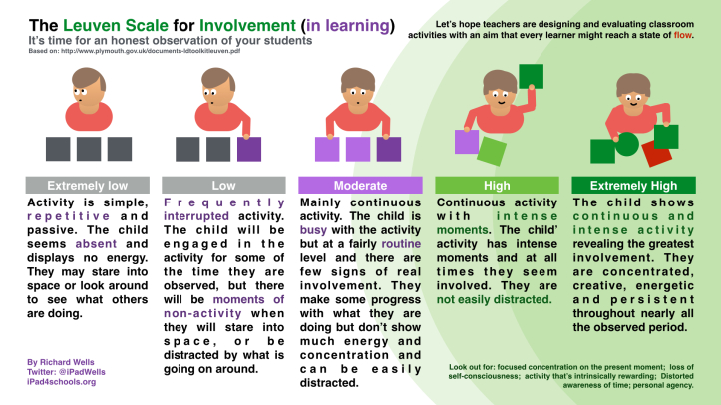

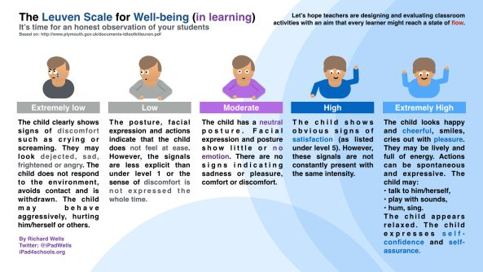
If necessary, we take a Spider-gram survey with a 1-5 range before the children start in Forest School for the first time and this covers confidence, feelings, sense, actions, behaviours and likes (these are changeable). The children will then be asked the same questions at the end of their Forest School experience to look gain feedback of improvements.
16) Fire Policy
Fires and fire lighting can be a valuable part of Forest School sessions. The fire often creates a focal point, provides warmth and comfort and the hypnotic nature of flames often calms and relaxes. In addition, children can enjoy tasty treats prepared on the fire, learn about cooking on a fire and managing risk. They can also learn about traditional techniques such as making charcoal for drawing. Fire lighting outside requires some skill and is reserved for older children. However, it teaches children responsible fire lighting and provides a real sense of mastery when accomplished.
At Forest School we aim to provide opportunities for the children to learn safe behaviour around the fire and experience all the above.

Procedure
A permanent fire site is on the site.
Logs for sitting on are placed at least 1m from the fire pit.
Fire gloves, water and a fire blanket are in designated place next to fire boundary.

The following rules of behaviour are explained and demonstrated to the children:
- Children can only enter the fire boundary with permission of an adult.
- When inside the boundary they must be seated on the logs or in fire stance.
- Children must never cross through the fire circle without permission.
- No running is allowed in the fire area.
- Only the Forest School Leader can add or put anything into the fire or with Forest Lead overseeing.
- If smoke blows in the direction of a child, they are advised to move away to a smoke free area, if safe to do so. Should it not be safe to move due to proximity of other children or potential trip hazard, they are advised to close their eyes and mouth and turn their head away from the smoke. An adult will then help them move if required.

Extinguishing the fire
Towards the end of the session the fire is allowed to die out.
Once reduced, any part burned logs are broken up using a fire poker.
Water is then poured slowly over the remains by the Forest Lead or by beginning at the outer edge and working in to the middle called the ‘fire closing ceremony.
Any larger pieces of unburnt wood are thoroughly soaked and removed.
The ash and water are stirred with the poker.

FOREST SCHOOL CLOTHING LIST GUIDE:
Below is an idea of what will be needed for Forest School sessions. We often talk about layering clothing but what does it actually mean and why is it important?
Layering means that clothes can be put on and taken off when necessary to keep a comfortable body temperature. Air is trapped in between the different layers and helps provide insulation. The outer layers can be removed if an individual is feeling too hot allowing the body temperature to drop to a comfortable level. Frequently children either wear too much clothing or clothing that is too bulky. This may prevent the child from moving easily and detracts from their ability to participate in outdoor activities. Keeping a base and mid layer on prevents the body temperature dropping too much when outer layers are removed. A comfortable body temperature prevents sweating during physical activity, this is important because once the activity stops the feeling of dampness from sweat can make you cold.
Getting the layers of clothing right really enables children to access their outdoor provision and forest school activities.
· Base layer - The base layer is the layer closest to your skin
· Mid layer - is to capture warmth through trapped air
· Top layer – is to provide extra warmth
· Outer waterproof layer – to protect from damp, wind and cold
· Protection for extremities – head, hands and feet
· Sun protection

AUTUMN/WINTER TERMS
During this time of year, the children need to be prepared for chilly and often wet sessions.
On Forest School days each child should ideally wear:
BASE LAYER:
Vest or thermal top
Tights or thermal leggings
MID LAYER
Long sleeved T-shirt top
Fleece top/jumper
Leggings/trousers (preferably a thicker type material for really cold weeks)
TOP LAYER – for really cold weeks
Thicker fleece /jacket
WATERPROOF LAYER
Waterproof jacket
Waterproof trousers or dungaree trousers
EXTREMITIES
FOOTWEAR
Tights or socks – would advise two pairs of socks in the colder weeks, feet get cold in wellies, also ensure you have a suitable size that will fit two pairs of socks – if the boot is too tight it will also make the feet colder.
HEAD AND HANDS
Wool hat and scarf/snood
Gloves/mittens
Welly boots / Snow boots are ok in cold/dry conditions- but not when we have lots of water.
In addition to the above could each child bring with them a bag containing spare clothing: Spare t-shirt, fleece top/jumper, trousers, pants, socks – x 2.

THE SUMMER TERM
At this time of year, the weather can of course be warm and sunny however it can often feel cooler in the woods and can be damp on the ground even during a sunny spell. Therefore, please ensure they come prepared. Please note full length sleeves and trousers must be worn to protect against thorns, stinging nettles, and ticks.
On Forest School days each child should be wearing:
BASE LAYER
T-shirt top (long sleeves please)
MID LAYER
Fleece top/jumper
Leggings/trousers to be tucked into socks (no shorts please, children must have full length trousers)
OUTER WATERPROOF LAYER
Waterproof jacket/trousers /dungarees
Sock’s (would advise two pairs of socks, feet get cold in wellies, be guided by the weather)
Sun hat
Welly boots (trainers if dry)
Sunscreen and mosquito spray (this must be applied by you, before the session)
In addition to the above each child needs to bring with them a bag with the following spare clothing:
Spare t-shirt, Fleece top/jumper, Trousers, Pants, Socks – x 2.

Clothing Care Advice
Waterproof clothing, if maintained in the correct way, should last for a long time, giving good value for money. However, you can very quickly reduce the effectiveness of waterproof material if washing too frequently or with the unsuitable products.
Caring for your waterproof clothing is a bit of a balance. Dirt and residue can build up on your waterproof clothing, affecting the garment’s breathability and waterproof efficiency.
Washing the garment too frequently reduces the effectiveness of waterproofing clothing. We have found over time that incorrect washing is the most common reason for waterproof clothing failure. You don’t need to wash them every time your child uses them.
Clothing is better left muddy than putting straight into the machine washing. Even if you are following care guides exactly, the waterproofing of a garment will be reduced each time they are machine-washed. Try not to wash waterproofs in the washing machine at all. Instead leave them muddy and brush the mud off when it dries or use a large bowl, bucket or even the bath to dip them clean (see below). The clothing rarely looks as clean as it did when brand new, but the waterproofs will last for as long as possible keeping your child dry, rather than looking pristine.
PLEASE REMEMBER to refer to the care labels for each specific garment and carefully follow the instructions.
Cleaning - The way you clean your waterproofs can make the difference between them lasting a few weeks to lasting a few years.
The ‘Dip wash’ way
Fill a bucket, bowl or even the bath with cool water
DO NOT ADD ANY DETERGENT
Before washing the garment, brush off any loose dry mud or dirt
Close zips, velcro fastenings and flaps on jackets and trousers
Put the waterproofs into the bucket or whatever you choose and slosh them around
A couple of water changes may be necessary if garments are particularly dirty
Hang up to dry in a position that allows air movement
Detergent - Waterproof clothing should never be washed using ordinary detergent or fabric softener. The chemicals in detergent can break down the composition of the fibres with each wash and strip the fabric of its waterproof coating.
Machine wash - Washing waterproof clothing in a machine, even if following care instructions carefully, can reduce their waterproof lifespan. If you do wash items in a machine, use a specialist cleaner – Nikwax wash and proof is ideal, but make sure the detergent compartment of your washing machine is clean of any normal washing detergent or softener. If you run a hot wash program whilst the machine is empty, prior to washing the waterproofs, it will clear any residue from detergent or softener.
Remember to always check the label of your garment for exact care details.
After washing the garment hang it up to air dry, or tumble dry on a low or medium heat, BUT ONLY IF the garment care instructions allow, please use a Low heat, as heat can affect waterproof materials. Most garment care labels will state NO HOT WASH AND NO TUMBLE DRY.
Storage - Make sure all waterproofs are dry before storing away, to avoid them becoming mouldy or musty. Also, avoid storing in direct sunlight.
If you notice that the fabric of your jacket or trousers is absorbing rather than repelling water you may need to re-waterproof your garment – products like Nikwax wash and proof, as mentioned above or similar products, are good for this, and you can get these from any outdoor/camping stores like Mountain Warehouse, Millets, Trespass, Decathlon or Go Outdoors.

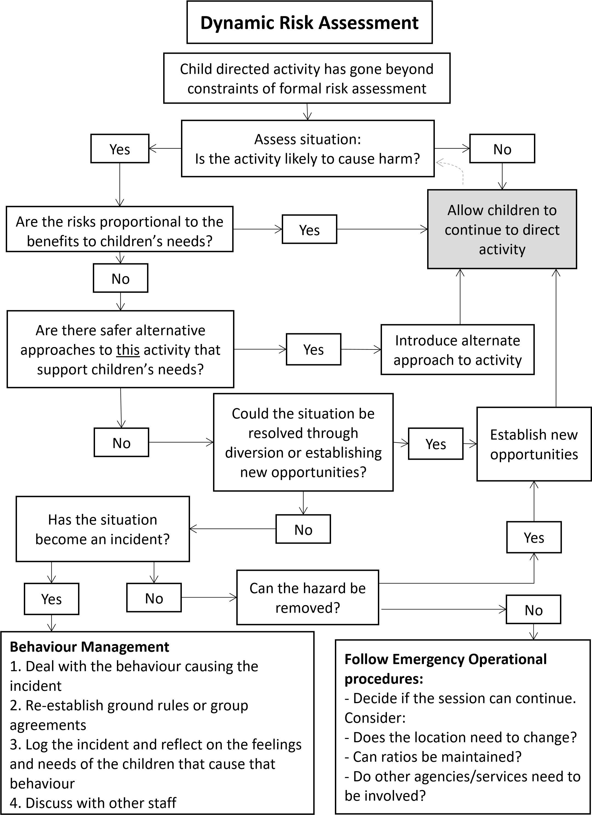
Forest School Tool Use Policies and Procedures
The Forest School ethos is to build on skills in small steps. Once the children and leaders have developed a trust and the children have shown they are ready, the leader will introduce more advanced skills such as tool use and fire, with close supervision.

Tools available for use are:
Bill hooks, bow saw, flint strikers, loppers, palm
Drills, mallets, peelers, secateurs, sheath knife
All tools are cleaned, maintained and stored securely by the Forest School leader.
- Prior to use, the Forest School leader will check the tools for any damage or instability and check for sharpness.
- Tools are transported to Forest School in a secure container.
- Only the Forest School leader’s tools can be used at Forest School.
- How to use all tools will be demonstrated on a group basis and then assessed on a 1:1 basis.
- Only the Forest School leader will decide if the age group / individual child is ready for a particular tool by assessing for competence on a 1:1 basis.

- As part of the process for assessing competence children must be able to have a good understanding of the ‘tool- talks’ seen in the ‘Tool Safety Procedures’ before being considered capable of using any particular tool.

Tool & Equipment Safe Procedures

Bill Hook - Tool Talk
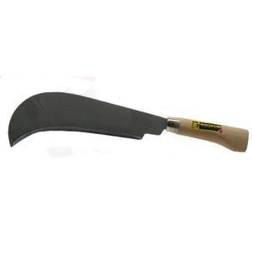
This is a bill hook.
This is the handle.
This is the cover.
I take the cover off like this.
This is the blade.
This is the cutting edge.

When I have finished with the bill hook I put the cover back on like this.
I stand with the bill hook like this.
I walk with the bill hook like this.
I pass the bill hook like this.
When I use the bill hook I use it two arms and a tool length away from anyone except my partner like this.
I use the bill hook to cleave (split) wood.
I have bare hands on the tool.
When I am not using the bill hook I put it down with the handle facing forwards and the hook and blade facing inwards.
When I have finished with the bill hook I put it in the designated place or in the toolbox provided
Splitting wood using a billhook with a partner:
Both face each other using the Respect Positions,
1 is the holder of the Bill Hook, 1 is the hitter.
The hitter asks how many times and how hard?
The holder says ‘1, softly’ (or medium, hard etc).
The hitter repeats asking until complete.
Bow Saw - Tool Talk

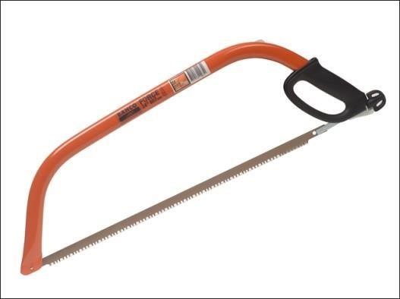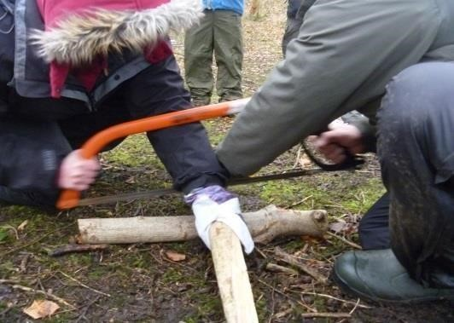

This is a bow saw.
This is the handle.
This is the cover.
I take the cover off like this.
This is the blade.
This is the cutting edge.

When I have finished with the bow saw I put the cover back on like this.
I stand with the bow saw like this.
I walk with the bow saw like this.
I pass the bow saw like this.
When I use the bow saw I use it two arms and a tool length away from anyone except my partner like this.
I use the bow saw to cut wood bigger than a two pence piece.
I have bare hands on the tool.
I have a glove on my ‘helper’ hand.

When I am not using the bow saw I put it down with the handle facing forwards and the blade facing inwards.

When I have finished with the bow saw I put it in the designated place or in the toolbox provided.

Junior Hacksaw - Tool Talk

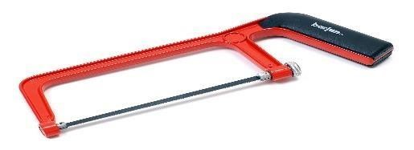

This is a hacksaw.
This is the handle.
This is the blade.
I never touch the blade.

I use the hacksaw for cutting small diameter twigs and lengths of wood.

I place the wood to be sawn on a flat, stable surface such as the log rounds.

I wear a glove on my non-sawing hand.

I am one arm and a tool length away from anyone else.

I walk with the hacksaw like this, with the blade facing behind me and down at my side.

When I pass the hacksaw, I pass it like this, handle first.

When I am not using the hacksaw I put it back in the designated box.

Flint and steel – Tool Talk

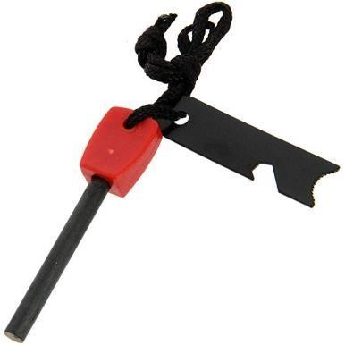

This is a flint and steel
I use the flint and steel to make a spark to light a fire.
This is the handle.
This is the steel.

When I use the flint and steel I am in fire/respect stance.

I am one arm and a tool away from anybody else.

I hold the steel in one hand with the rod facing away from my body. I scrape the striker along the metal rod, away from my body, like this.

When I have finished I put the flint and steel in the designated place.

Loppers - Tool Talk

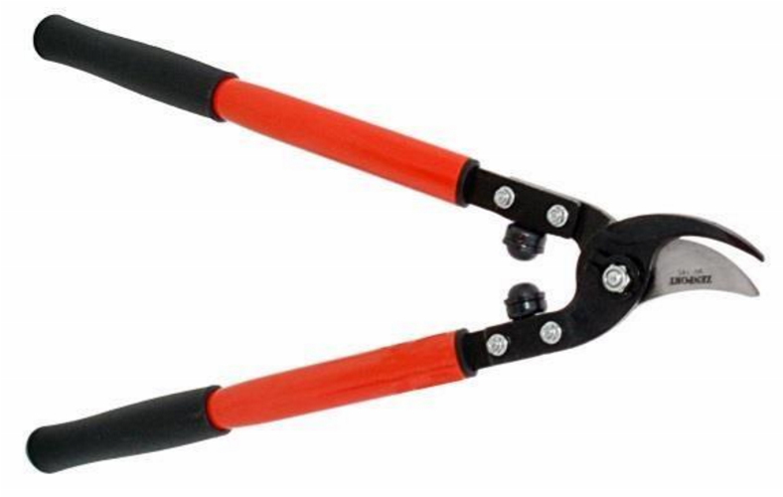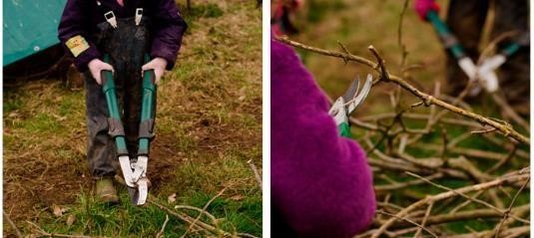

This is a pair of loppers.
This is the handle.
This is the blade.
This is the cutting edge.

I hold the loppers like this.

I walk with the loppers like this, down by my side.

I pass the loppers like this.

When I am not using the loppers I put them on the ground with the handles facing forwards and the blade facing behind me.

I use the loppers to cut anything smaller in diameter than a 2 pence piece.

I use the loppers, one arm and a tool length away from anyone else.
When I have finished using the loppers I put them back in the designated place.

Mallet - Tool Talk

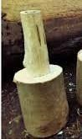

This is a mallet.
This is the handle.
This is the head.

I use the mallet for hitting the back of the axe for splitting wood and for banging tent pegs or stakes into the ground.
I am one arm and a tool length away from anyone else.
I walk with the mallet at my side like this.
When I am not using the mallet I put it back in the designated box.

Palm Drill - Tool Talk

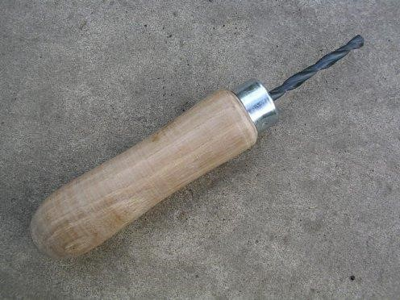

This is a palm drill.
This is the handle.
This is the drill.

I use the drill to make holes in wood no bigger than 2.5cm thick.

I place my wood to be drilled, on a flat surface.

I hold my palm drill like this, I push and turn my palm drill like this, holding it upright.

I am one arm and a tool length away from anyone else.

I walk with the palm drill like this, with the drill pointing down by my side.

When I pass the palm drill, I pass the handle first.

When I am not using the palm drill I put it back in the designated box.

Peeler (whittler) - Tool Talk



This is a safety whittler.
This is the handle.
This is the blade.

These are the cutting edges.

I use the whittler for green wood only.

I hold the handle like this.

I sit or am in fire stance when I use the whittler.

I strike away from my body.

I am one arm and a tool length away from anyone else.

When I am not using the safety whittler, I put it back in the
designated box.

Secateurs – Tool talk

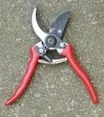

This is a pair of secateurs.
This is the handle.
This is the blade.
This is the cutting edge.

I hold the secateurs like this.

I lock the secateurs like this.

I walk with the secateurs like this, down by my side.

I pass the secateurs like this.

I use the secateurs to cut anything smaller than my thumb.

I use the secateurs one arm and a tool length away from anyone else.
When I am not using the secateurs, I lock them and put them back in the appropriate tub.

Sheath Knife - Tool Talk

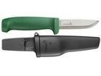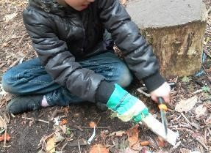

This is a sheath knife.
This is the handle.
This is the sheath.
This is the blade.
This is the cutting edge.

I always use on the outside of my body with the blade facing away from me.

When not using it, I put it back in the sheath like this.

I hold it like this.
I carry it like this.
I pass it like this.

When using the sheath knife I always cut down and away from my body.

When possible, I whittle onto a flat wood surface.

I always use it one arm and a tool length away from anyone else.

When I have finished using it, I put it away in the designated place.

No gloves on tool - glove on non-knife hand.

Kelly Kettle - Safe Use procedure

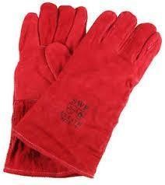
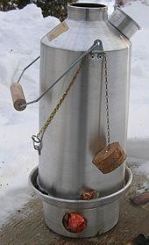
Place the base of the kettle on a flat, non-flammable surface in the designated area.
Ensure the inlet hole in the base is turned towards the wind.
Make a platform of small kindling in the base, place cotton wool or firelighter on platform. Whilst in fire stance, light the cotton wool with a flint steel.
Add short pieces of extra kindling.
Remove the stopper from the spout of the water jacket and hook over the handle before placing the kettle onto the base, ensuring the spout is opposite the inlet hole.
Add kindling to the chimney to feed fire, keeping fingers to the side as flames will come out of the chimney.
Use two hands and hold handle horizontal to lift kettle on and to remove. Always ensure the spout is facing away from you to avoid splashes. Use chain to tip and pour or use fire glove to tip the base of the water jacket.
Once boiled, extinguish the flames with water, place water jacket back in designated area. Ensure kettle and base are fully cooled before replacing in carry bag.

NOTES:

